**EXPERIMENT NUMBER: 2**

**Student Name: Lagan Verma UID:20BCS3515**

**Branch: Information Security Section/Group: 20BIS1/A**

**Semester: 5th Date of Performance: 15.08.2022**

**Subject Name: Network Defense Essentials Lab Subject Code: 20CSB-331**

**1. AIM/OVERVIEW OF THE PRACTICAL:**

Implementing role-based access controls in windows administrator.

**2. TASK TO BE DONE:**

Sign in the Windows admin centre and create user and grant the permissions in Azure Microsoft.

**3. STEPS FOR EXPERIMENT/PRACTICAL:**

1.Register with Azure.

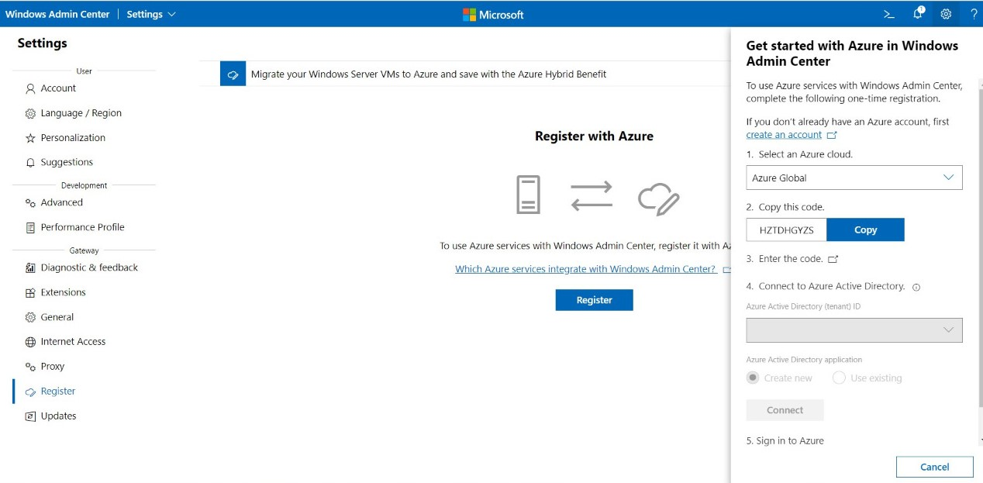

2.Sign-In the windows admin centre using new created mail id.

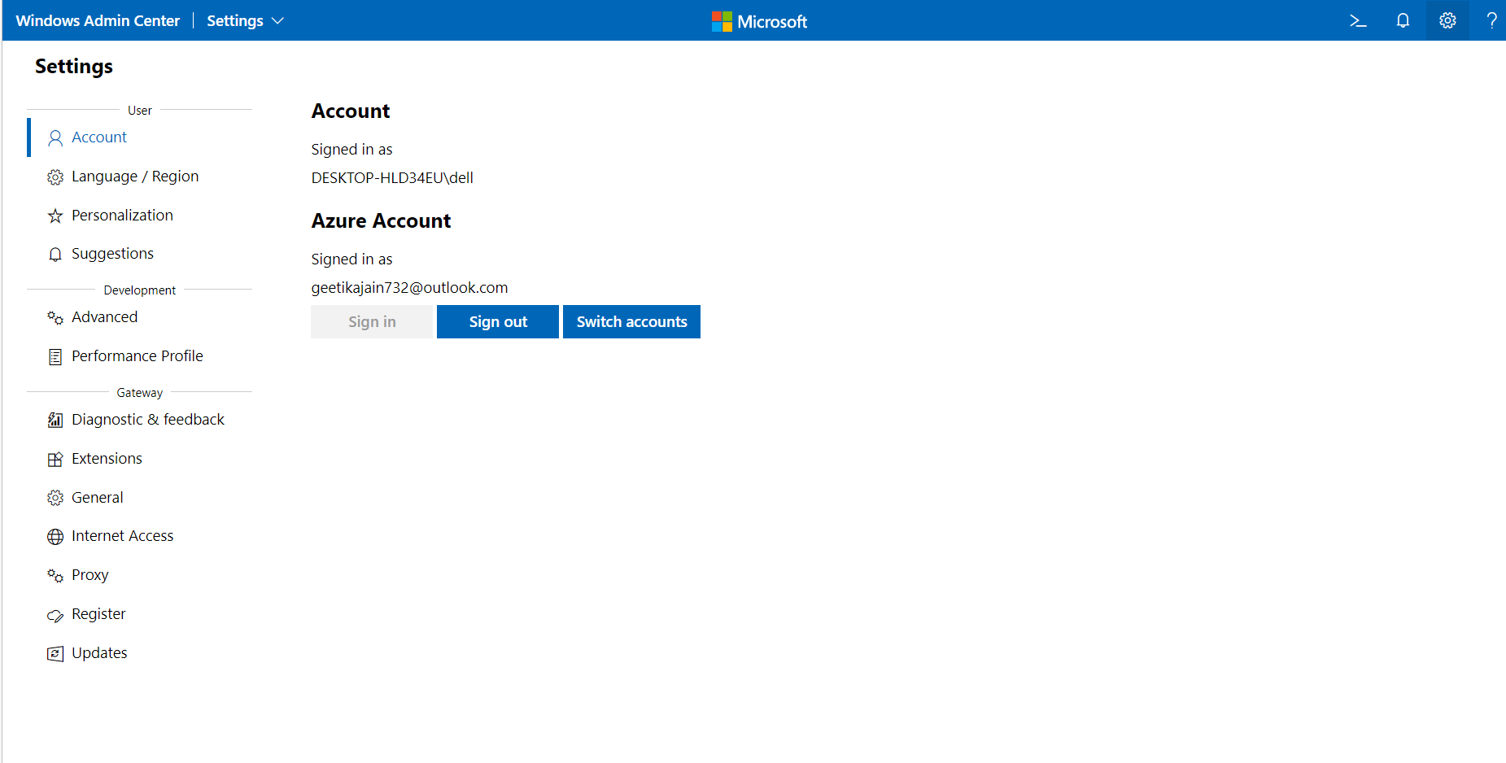

3.Go to Azure AD roles and administrator. Check for the role(here: Global Administrator)

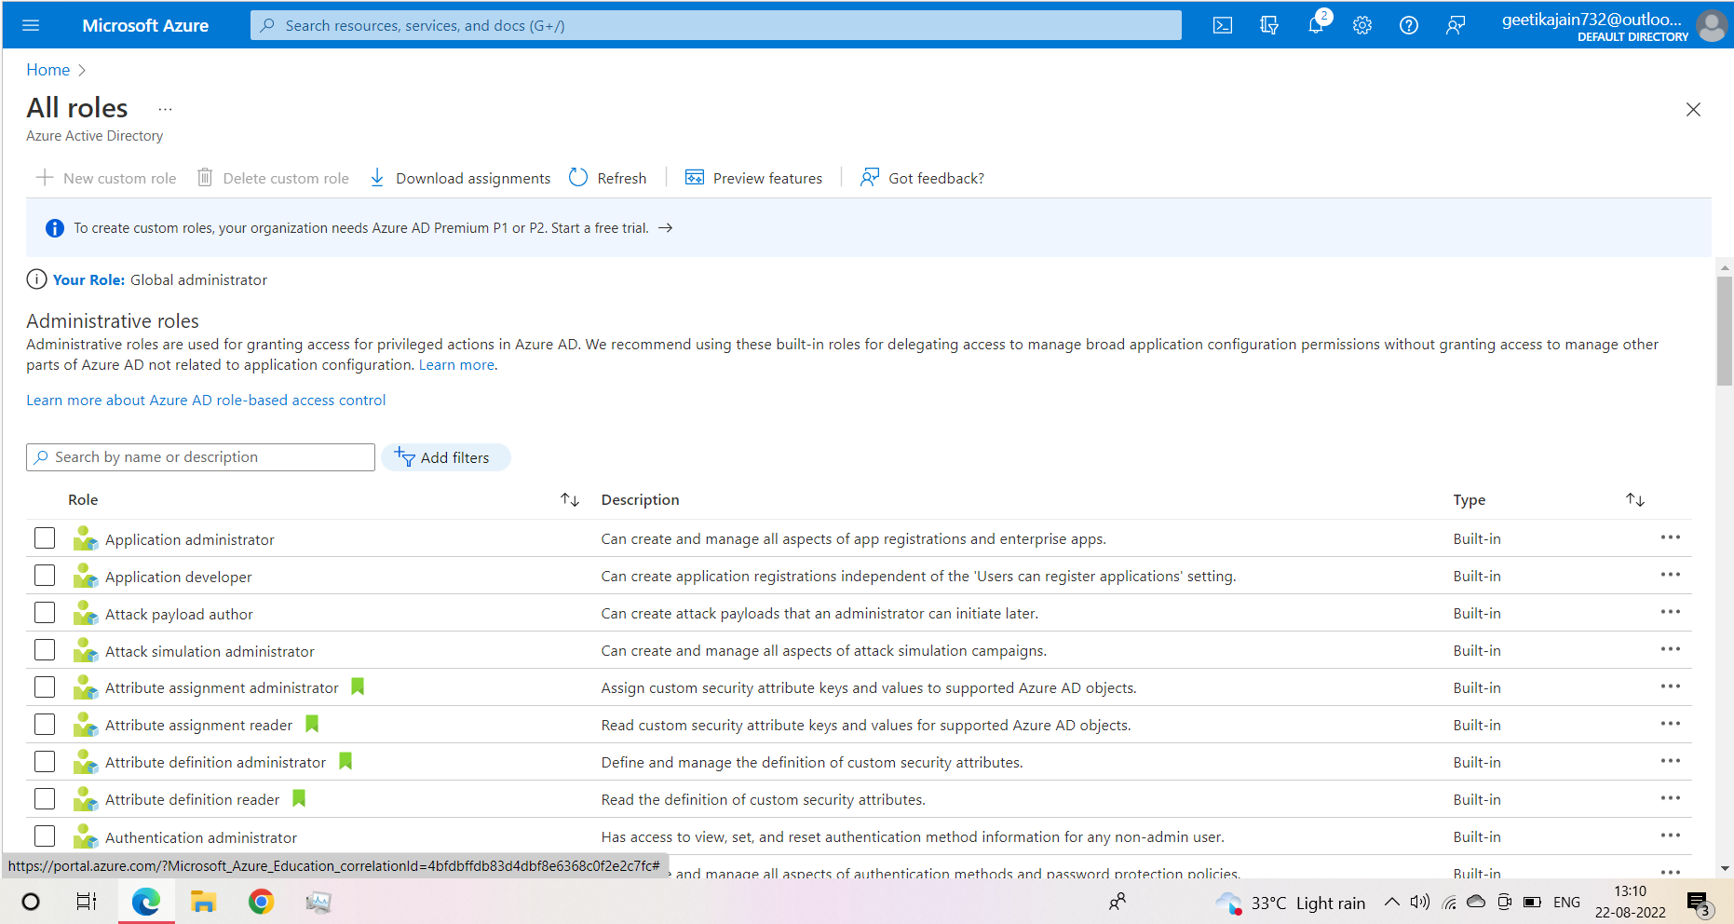

4.Click on Role, then click on the add assignment option. Search for the user and then tick the permission which needs to granted. (Here: Directory Writers)

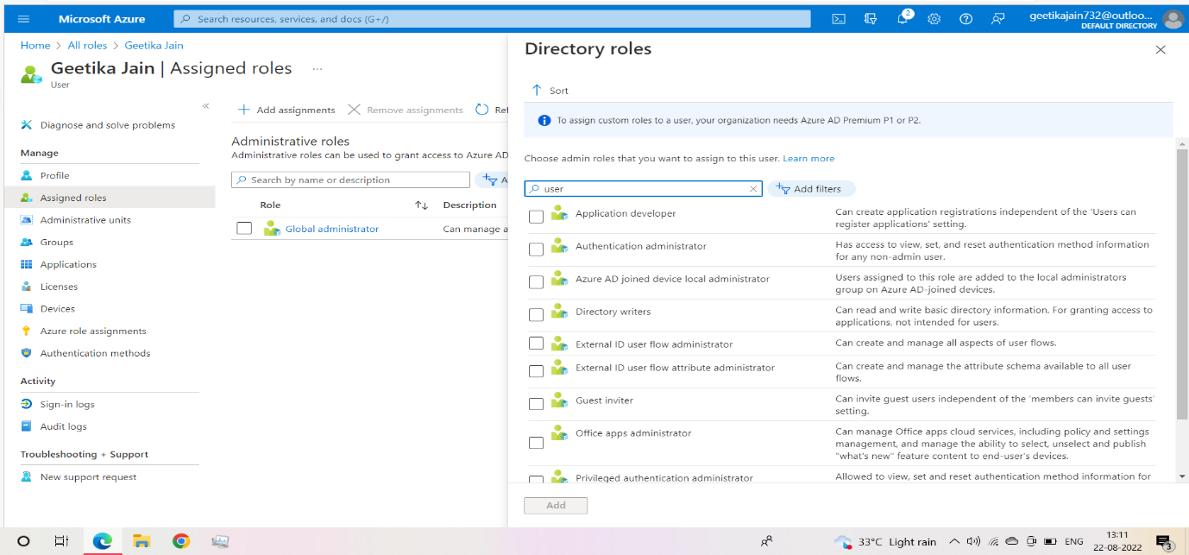

5.Click on the assigned roles to check for the permissions given to user.

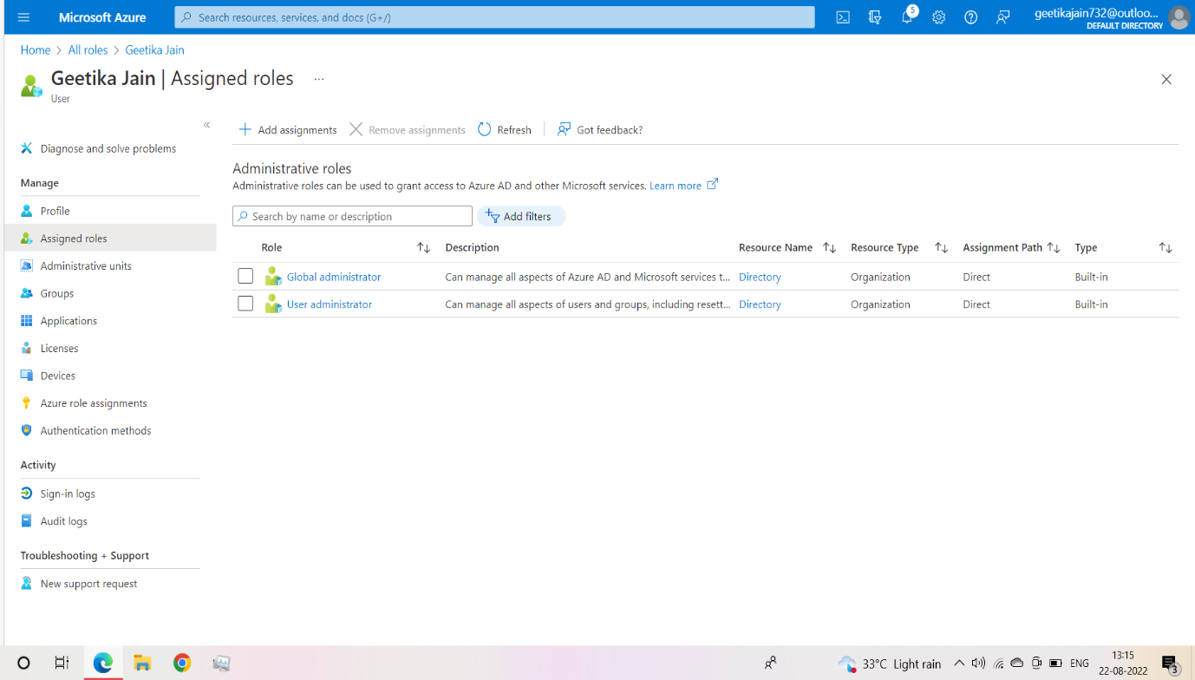

**Learning outcomes (What I have learnt):**

1. Learnt about the Role-Based access controls.
2. Implemented the concept to use Microsoft azure account in the windows admin centre.
3. Established the concept to grant different permissions to the role based (here: global administrator).

\

Evaluation Grid (Created as per the Assessment Model):

|  |  |  |  |
| --- | --- | --- | --- |
| Sr. No. | Parameters | Marks Obtained | Maximum Marks |
| 1. | Worksheet completion |  | 8 |
| 2. | Conduct of Experiment |  | 12 |
| 3. | Quiz/Viva Voce |  | 10 |
|  | Total |  | 30 |